**Manuals for ‘Manage Albums’**

**Brief of the ‘Manage Albums’ –** This is the page where we manage Albums.

**1. How to manage Albums-.**

Steps:

1. Login to the site and go to ‘Media Room’ tab and click on ‘Manage Albums’.
2. On ‘Manage Albums’ page the listing of albums and ‘Add Albums’ button will display.
3. On this page we can edit and delete the existing records.
4. Click on ‘Add Albums’ button for add new records.

1.

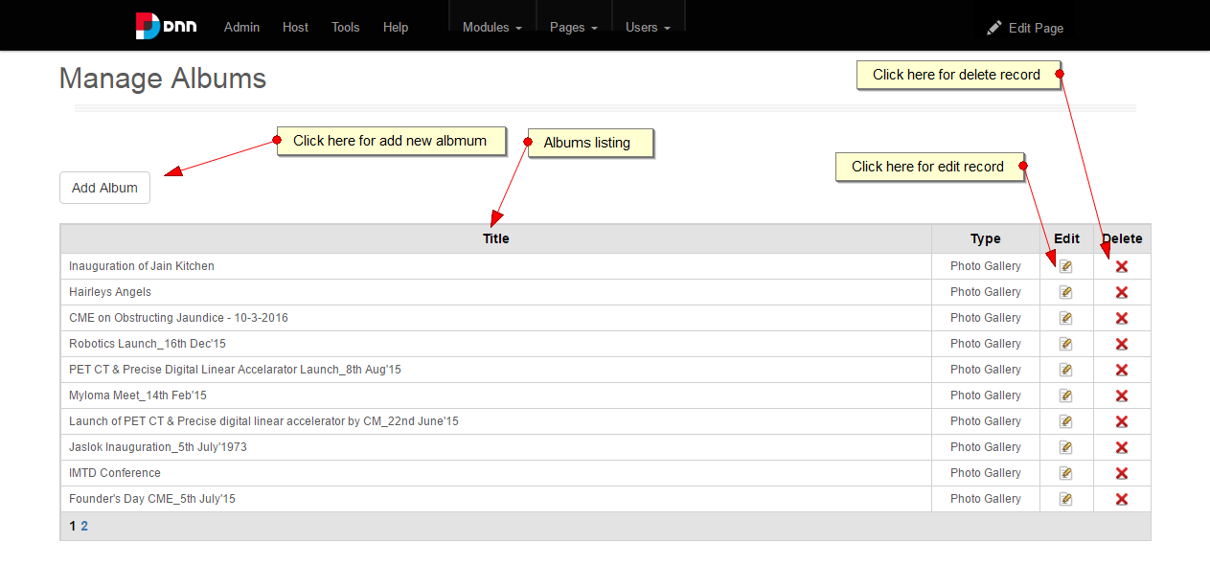

2.

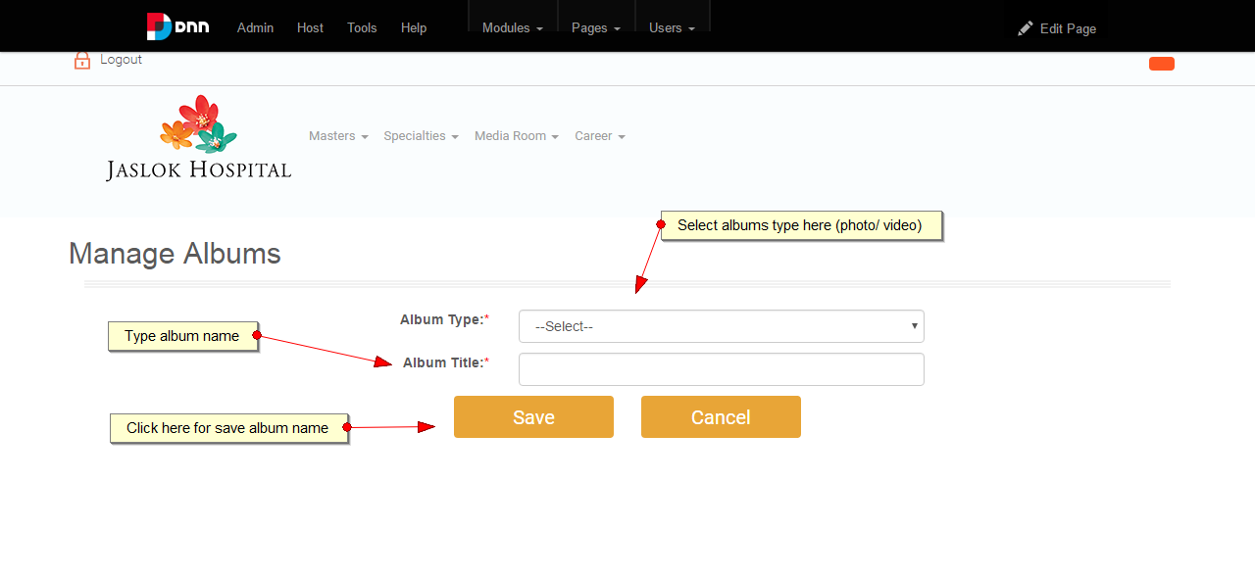

3.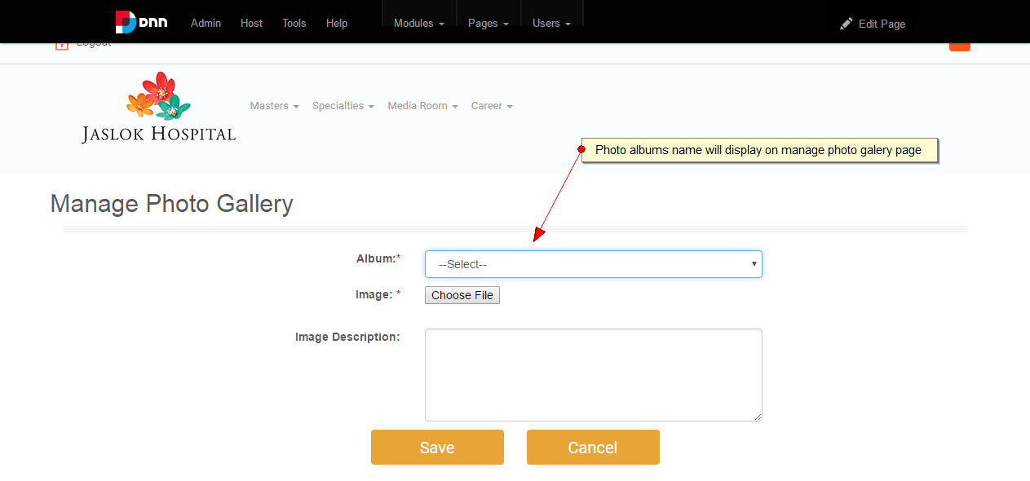

4.

